|  |  |  |  |  |  |  |  |  |  |  |  |  |  |  |  |  |
| --- | --- | --- | --- | --- | --- | --- | --- | --- | --- | --- | --- | --- | --- | --- | --- | --- |
|  | Unit Tag: AHU-0 | | | |  |  |  | | --- | --- | --- | |  | | | | 13600 Industrial Park Blvd. Minneapolis, MN 55441 | | | | www.DaikinApplied.com | Software Version: 06.60 |  | | | | |
| Product: PreciseLine® Air Handler | Project Name: 1095040 - NDSU Engineering Building 2024 | | |
| Model: BCVE0501 | Sales Office: SVL INC | | |
| Sales Engineer: | July 28, 2025 | Ver/Rev: | Sheet 1 of 1 | Scale: NTS | Tolerance: +/-0.25” | Dwg Units: in [mm] |
| No change to this drawing may be made unless approved in writing by Daikin Applied. Purchaser must determine that the equipment is fit and sufficient for the job specifications. | | | | | | |

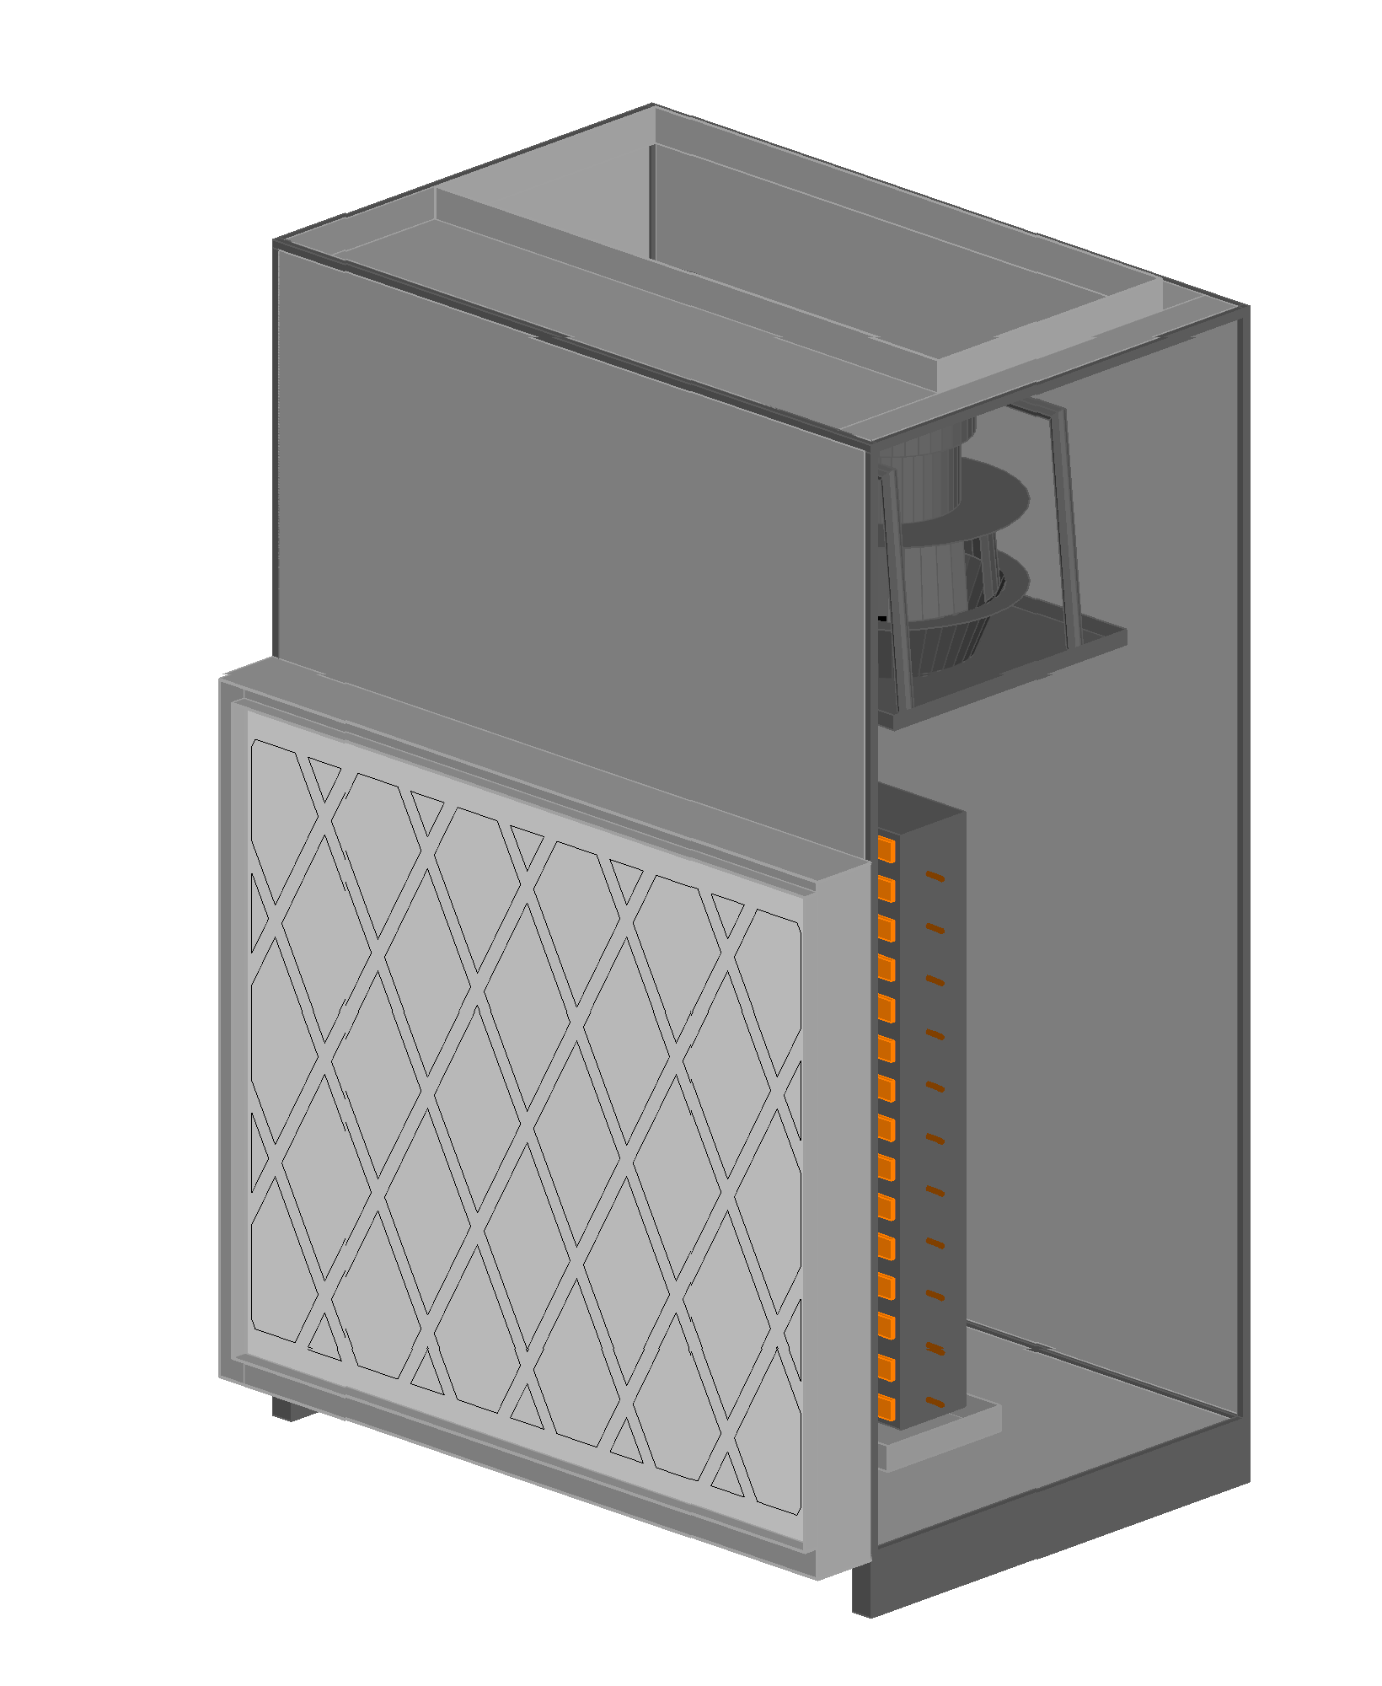

|  |  |  |  |  |  |  |  |  |  |  |  |  |  |  |  |  |
| --- | --- | --- | --- | --- | --- | --- | --- | --- | --- | --- | --- | --- | --- | --- | --- | --- |
|  | Unit Tag: AHU-0 | | | |  |  |  | | --- | --- | --- | |  | | | | 13600 Industrial Park Blvd. Minneapolis, MN 55441 | | | | www.DaikinApplied.com | Software Version: 06.60 |  | | | | |
| Product: PreciseLine® Air Handler | Project Name: 1095040 - NDSU Engineering Building 2024 | | |
| Model: BCVE0501 | Sales Office: SVL INC | | |
| Sales Engineer: | July 28, 2025 | Ver/Rev: | Sheet 1 of 1 | Scale: NTS | Tolerance: +/-0.25” | Dwg Units: in [mm] |
| No change to this drawing may be made unless approved in writing by Daikin Applied. Purchaser must determine that the equipment is fit and sufficient for the job specifications. | | | | | | |

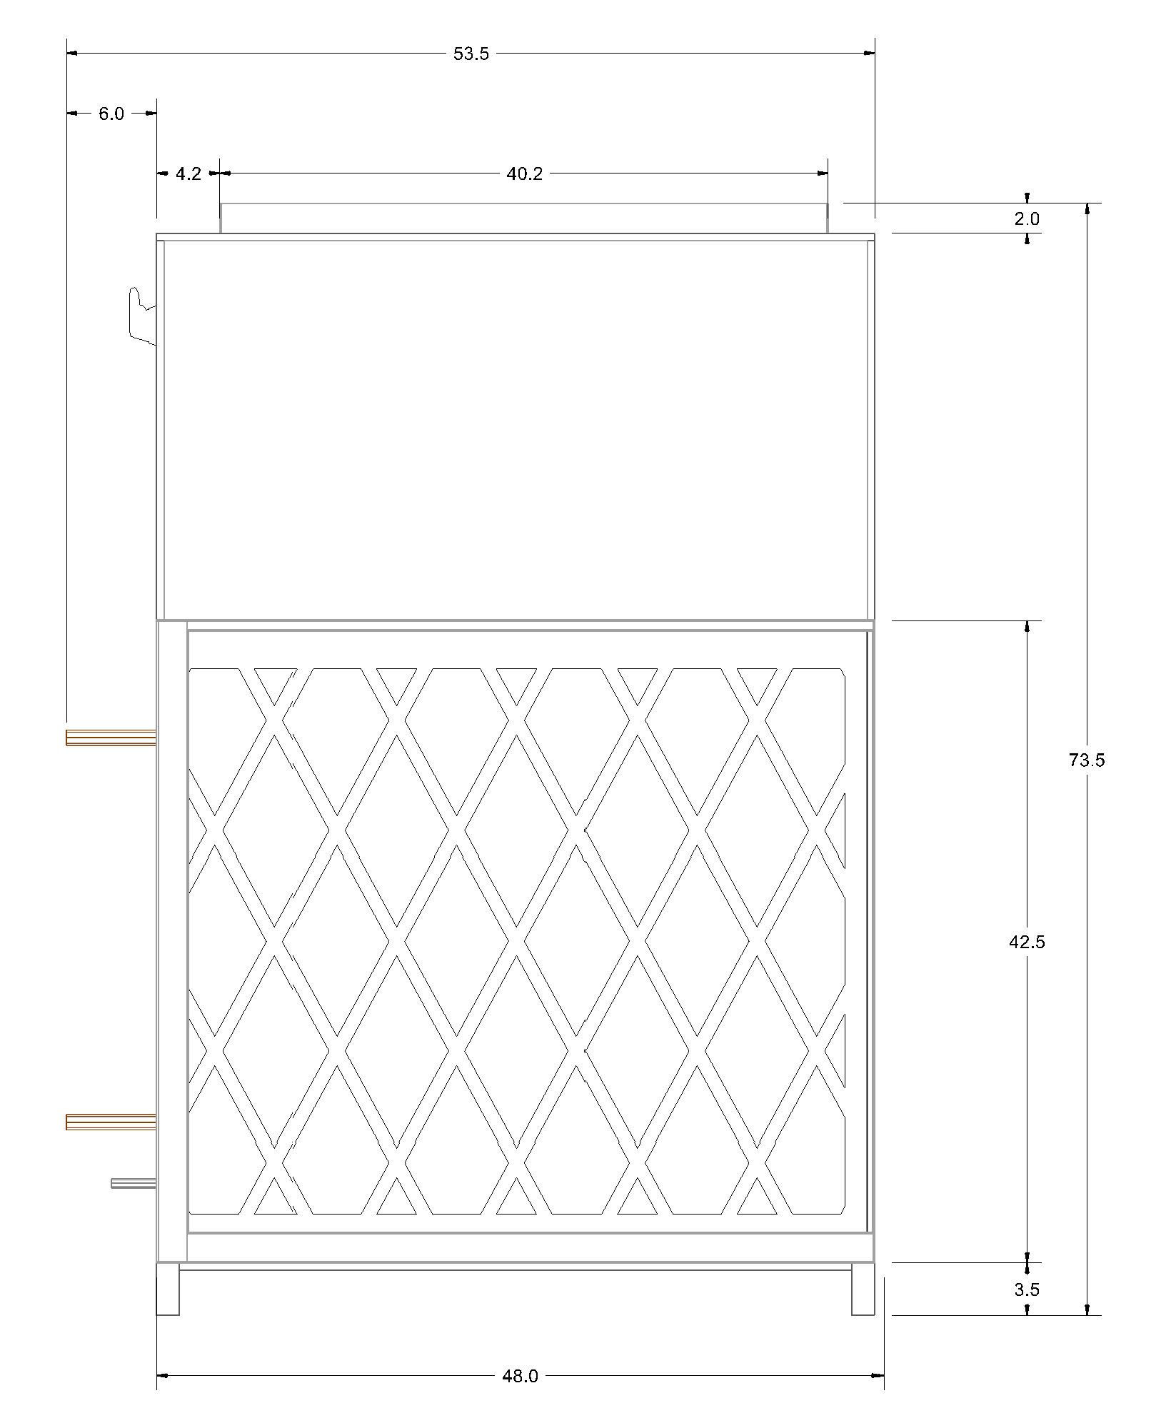

|  |  |  |  |  |  |  |  |
| --- | --- | --- | --- | --- | --- | --- | --- |
|  | | | | | | | |
|  | Unit Tag: AHU-0 | | | Sales Office: SVL INC | | | |  |  |  | | --- | --- | --- | |  | | | | 13600 Industrial Park Blvd. Minneapolis, MN 55441 | | | | www.DaikinApplied.com | Software Version: 06.60 |  | | |
| Product: PreciseLine® Air Handler | Project Name: 1095040 - NDSU Engineering Building 2024 | | | Sales Engineer: | | |
| Model: BCVE0501 | July 28, 2025 | Ver/Rev: | Sheet: 1 of 1 | Scale: NTS | Tolerance: +/- 0.25” | Dwg Units: in [mm] |
| No change to this drawing may be made unless approved in writing by Daikin Applied. Purchaser must determine that the equipment is fit and sufficient for the job specifications. | | | | | | | |

|  |  |  |  |  |  |  |  |  |  |  |  |  |  |  |  |  |
| --- | --- | --- | --- | --- | --- | --- | --- | --- | --- | --- | --- | --- | --- | --- | --- | --- |
|  | Unit Tag: AHU-0 | | | |  |  |  | | --- | --- | --- | |  | | | | 13600 Industrial Park Blvd. Minneapolis, MN 55441 | | | | www.DaikinApplied.com | Software Version: 06.60 |  | | | | |
| Product: PreciseLine® Air Handler | Project Name: 1095040 - NDSU Engineering Building 2024 | | |
| Model: BCVE0501 | Sales Office: SVL INC | | |
| Sales Engineer: | July 28, 2025 | Ver/Rev: | Sheet 1 of 1 | Scale: NTS | Tolerance: +/-0.25” | Dwg Units: in [mm] |
| No change to this drawing may be made unless approved in writing by Daikin Applied. Purchaser must determine that the equipment is fit and sufficient for the job specifications. | | | | | | |

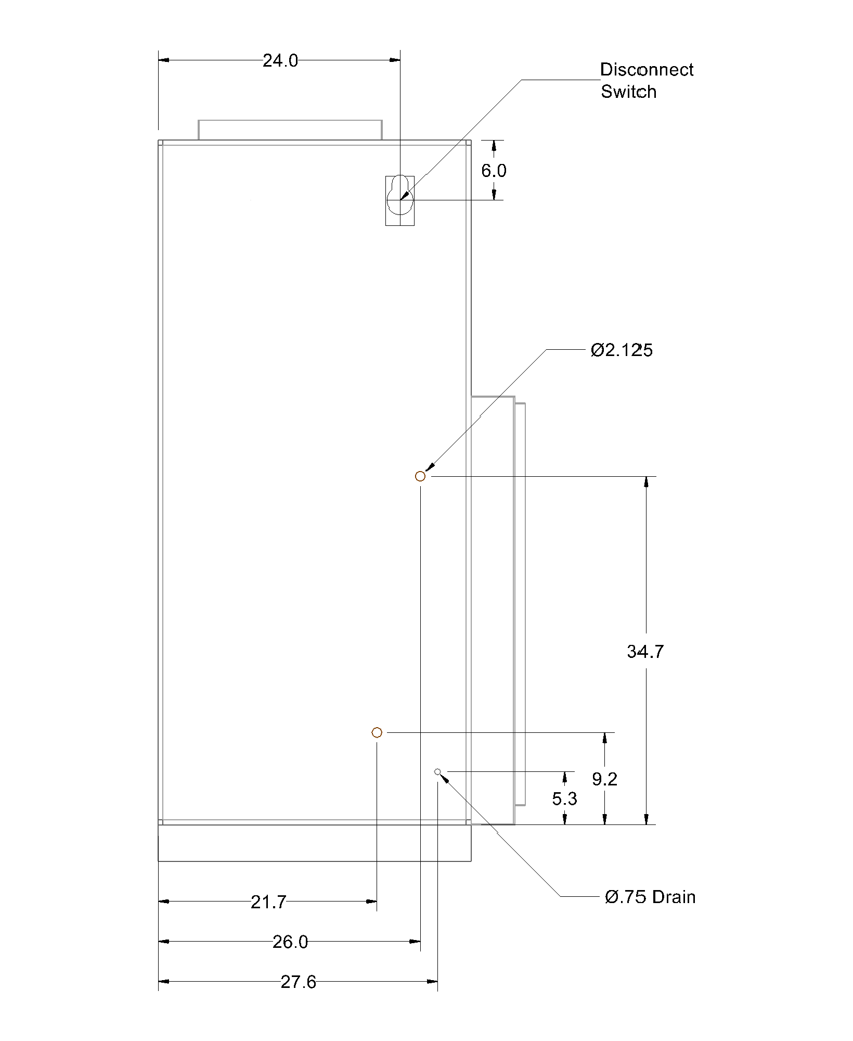

|  |  |  |  |  |  |  |  |  |  |  |  |  |  |  |  |  |
| --- | --- | --- | --- | --- | --- | --- | --- | --- | --- | --- | --- | --- | --- | --- | --- | --- |
|  | Unit Tag: AHU-0 | | | |  |  |  | | --- | --- | --- | |  | | | | 13600 Industrial Park Blvd. Minneapolis, MN 55441 | | | | www.DaikinApplied.com | Software Version: 06.60 |  | | | | |
| Product: PreciseLine® Air Handler | Project Name: 1095040 - NDSU Engineering Building 2024 | | |
| Model: BCVE0501 | Sales Office: SVL INC | | |
| Sales Engineer: | July 28, 2025 | Ver/Rev: | Sheet 1 of 1 | Scale: NTS | Tolerance: +/-0.25” | Dwg Units: in [mm] |
| No change to this drawing may be made unless approved in writing by Daikin Applied. Purchaser must determine that the equipment is fit and sufficient for the job specifications. | | | | | | |

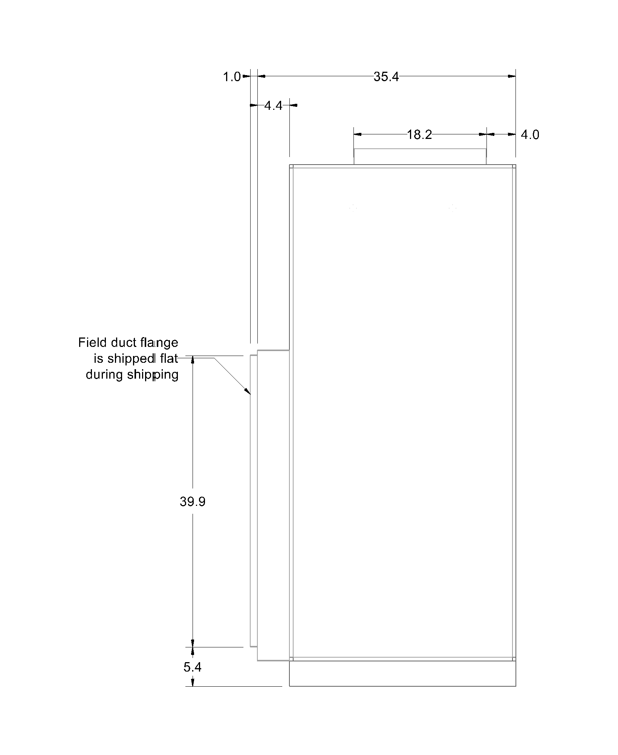

|  |  |  |  |  |  |  |  |  |  |  |  |  |  |  |  |  |
| --- | --- | --- | --- | --- | --- | --- | --- | --- | --- | --- | --- | --- | --- | --- | --- | --- |
|  | Unit Tag: AHU-0 | | | |  |  |  | | --- | --- | --- | |  | | | | 13600 Industrial Park Blvd. Minneapolis, MN 55441 | | | | www.DaikinApplied.com | Software Version: 06.60 |  | | | | |
| Product: PreciseLine® Air Handler | Project Name: 1095040 - NDSU Engineering Building 2024 | | |
| Model: BCVE0501 | Sales Office: SVL INC | | |
| Sales Engineer: | July 28, 2025 | Ver/Rev: | Sheet 1 of 1 | Scale: NTS | Tolerance: +/-0.25” | Dwg Units: in [mm] |
| No change to this drawing may be made unless approved in writing by Daikin Applied. Purchaser must determine that the equipment is fit and sufficient for the job specifications. | | | | | | |



|  |  |  |  |  |  |  |  |
| --- | --- | --- | --- | --- | --- | --- | --- |
|  | | | | | | | |
|  | Unit Tag: AHU-0 | | | Sales Office: SVL INC | | | |  |  |  | | --- | --- | --- | |  | | | | 13600 Industrial Park Blvd. Minneapolis, MN 55441 | | | | www.DaikinApplied.com | Software Version: 06.60 |  | | |
| Product: PreciseLine® Air Handler | Project Name: 1095040 - NDSU Engineering Building 2024 | | | Sales Engineer: | | |
| Model: BCVE0501 | July 28, 2025 | Ver/Rev: | Sheet: 1 of 1 | Scale: NTS | Tolerance: +/- 0.25” | Dwg Units: in [mm] |
| No change to this drawing may be made unless approved in writing by Daikin Applied. Purchaser must determine that the equipment is fit and sufficient for the job specifications. | | | | | | | |

|  |  |  |  |  |  |  |  |
| --- | --- | --- | --- | --- | --- | --- | --- |
|  | | | | | | | |
|  | Unit Tag: AHU-0 | | | Sales Office: SVL INC | | | |  |  |  | | --- | --- | --- | |  | | | | 13600 Industrial Park Blvd. Minneapolis, MN 55441 | | | | www.DaikinApplied.com | Software Version: 06.60 |  | | |
| Product: PreciseLine® Air Handler | Project Name: 1095040 - NDSU Engineering Building 2024 | | | Sales Engineer: | | |
| Model: BCVE0501 | July 28, 2025 | Ver/Rev: | Sheet: 1 of 1 | Scale: NTS | Tolerance: +/- 0.25” | Dwg Units: in [mm] |
| No change to this drawing may be made unless approved in writing by Daikin Applied. Purchaser must determine that the equipment is fit and sufficient for the job specifications. | | | | | | | |